**Logistic Performance Improvements**

Sean Keery – [skeery@pivotal.io](mailto:skeery@pivotal.io), @seankeery

Johnny Zhu - [johnnyzhu@g.harvard.edu](mailto:johnnyzhu@g.harvard.edu), @zhujohnny

Carlos Carpi - [cc3065@gmail.com](mailto:cc3065@gmail.com), @krpz

<http://harvard-team-pivot.github.io/cs171project>

<https://github.com/harvard-team-pivot/cs171project>

**Background and Motivation**

What’s slowing your package down?

As a first world consumer, I want to know why that widget I ordered is taking so long to get from place A, where it was produced, to me (place b.) As a manufacturer trying to get my widget to market quickly, what factors may influence where I produce it. As a manufacturer, I need to know which politicians to bribe in order to remove barriers to trade or greenlight permits (this is a stretch goal as we would need to correlate some data we haven’t reviewed yet.)

**Related Work**

The Logistics Performance Index overall score reflects assessments of a country's logistics based on efficiency of the customs clearance process, quality of trade- and transport-related infrastructure, ease of arranging competitively priced shipments, quality of logistics services, ability to track and trace consignments, and frequency with which shipments reach the consignee within the scheduled time. The index ranges from 1 to 5, with a higher score representing better performance.

<http://data.worldbank.org/data-catalog/logistics-performance-index>

Anything that inspired you, such as a paper, a web site, visualizations we discussed in

class, etc.

Mike Bostock, Adrian Cockcroft and y’all.

Process Book -> <https://github.com/harvard-team-pivot/cs171project/blob/master/README.md>

Project Objectives and Goals

Objective

Identify high performing regions and countries

Provide comparison of countries by component

Illustrate how miserable it can be to trade between certain places

What would you like to learn and accomplish?

What's a given countries ability to trade?

With other countries?

Within region?

What direction is the country moving?

Learn to work as a team under a deadline with set goals. Provide an engaging site while exploring the limits of web based visualization

List the benefits.

Benefit 1

Benefit 2

Benefit 3

One anti-goal is to produce reams of documentation. We understand there is more value in producing valuable visualizations than writing detailed plans that will change as soon as the ink is dry.

Tasks

Describe in detail which data manipulations (sort, filter,..) and visual manipulations (zoom,

selection,…) you want to implement and how these support the goals.

Data. From where and how are you collecting your data? If appropriate, provide a link to your data

sources.

Data Processing.

Do you expect to do substantial data cleanup? What quantities do you plan to derive

from your data? How will data processing be implemented?

Visualization Design.

How will you display your data? Provide some general ideas that you have for

the visualization design. Develop three alternative prototype designs for your visualization.

Create one final design that incorporates the best of your three designs. Describe your designs and justify your choices of visual encodings. We recommend you use the Five Design Sheet

Methodology

An agile methodology will be used to manage the project.

Brainstorming session

Initial Designs

Layout, focus, operations, pros & cons, meta

1. Individually write down on sticky‐notes their own thoughts
2. Collate all sticky‐notes (the ideas) in the group
3. Stack the sticky‐notes of similar ideas on top of each other
4. In the group organize the sticky‐notes
5. Categorize the idea space by moving the stick‐notes into groups of like‐ideas
6. Combine and refine the ideas: Use sketching and start to prepare the three main design‐sheets
7. Start to discuss the benefits/challenges: or advantages/disadvantages of the categorized ideas

* concept
* Many alternatives are considered
* Design improvements
* Better understanding of requirements
* Iterate 2–4
* Few alternatives considered
* Completed design

Pipeline

1. Target

Choose domain

Define Question

Explore existing solutions

Formulate data analysis tasks

2. Data Wrangling

Find and clean data

EDA (exploratory data analysis)

Transform and summarize data

3. Design

Design visual encoding

design interactions

design layout and storytelling

4. Implement

Rapid prototypes

define data structure

explore efficient algorithms

design system architecture

5. Evaluate

Is the abstract right?

Do encoding and interaction

…support the task?

…provide (new) insights?

screencast

Interactions storyboard

Project re-design

Project prototypes V1 and V2

Project review with the staff (in studio)

Peer feedback (in studio)

Final project submission (including screen-cast)

Group peer evaluations

Project demos

Must-Have Features. List the features without which you would consider your project to be a failure.

Epic - storyboard

Epic - interaction

Epic - encoding

Epic – poster session

Epic -

Review

Tasks

Implement multiple coordinated (linked) views

One innovative view that is either

a) an extension of an existing visualization type, or

b) a novel visualization type

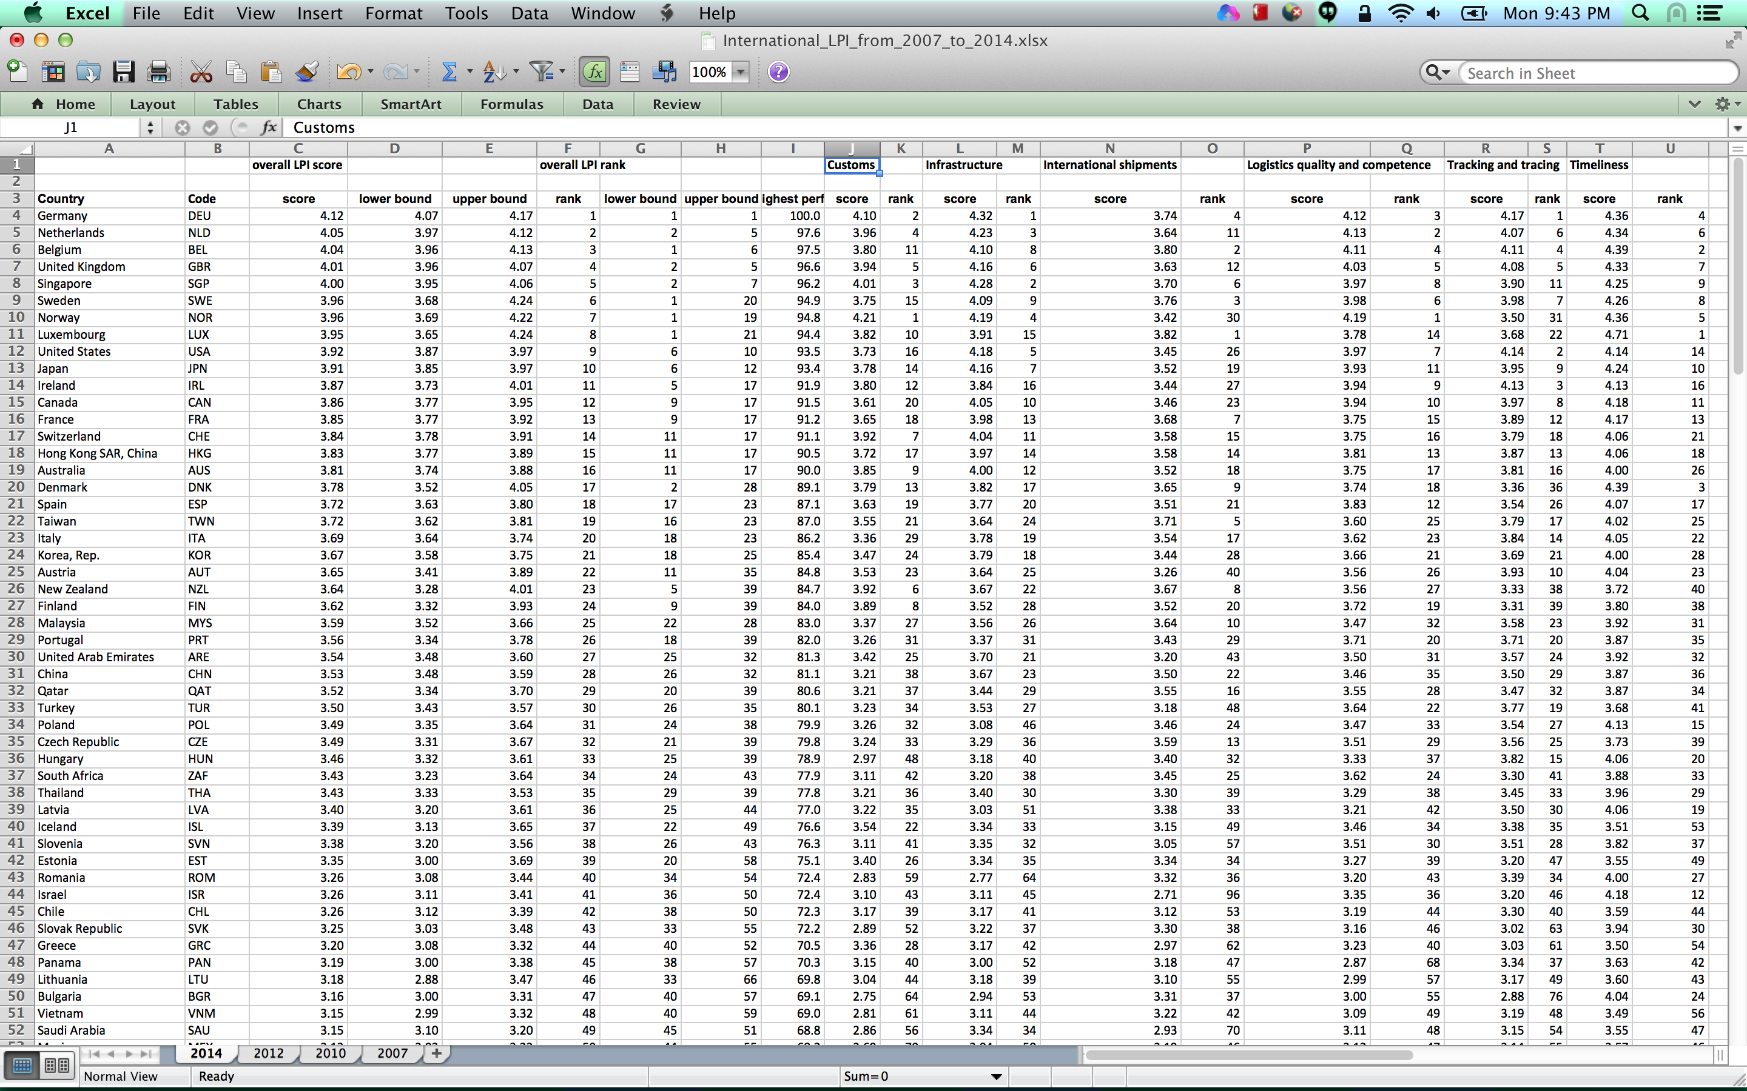

Data Screenshot

**Data Definitions**

The international score uses six key dimensions to benchmark countries' performance and also displays the derived overall LPI index. The logistics performance (LPI) is the weighted average of the country scores on the six key dimensions: 

1) Efficiency of the clearance process (i.e., speed, simplicity and predictability of formalities) by border control agencies, including customs;

2) Quality of trade and transport related infrastructure (e.g., ports, railroads, roads, information technology);

3) Ease of arranging competitively priced shipments;

4) Competence and quality of logistics services (e.g., transport operators, customs brokers);

5) Ability to track and trace consignments;

6) Timeliness of shipments in reaching destination within the scheduled or expected delivery time.

The scorecards demonstrate comparative performance—the dimensions show on a scale (lowest score to highest score) from 1 to 5 relevant to the possible comparison groups—of all countries (world), region and income groups.

Optional Features. List the features which you consider to be nice to have, but not critical.

Project Schedule. Make sure that you plan your work so that you can avoid a big rush right before the final project deadline, and delegate different modules and responsibilities among your team members.

Mindmap



Write your schedule in terms of weekly deadlines.

Week 1 – map vis

Week 2 – linked vis

Week 3 – interactions & final site

